Activity 1: Containerize the Java (Spring boot) Application
- Spring boot: This helps in building web based java applications with built in middleware
- Generally to extension of the java package is jar to run the spring boot application the command is java -jar <package>.jar
- Lets try to run an application spring pet clinic
- To run this application we need java 11
- when we run this application it exposes port 8080
- Manual steps
sudo apt update
sudo apt install openjdk-11-jdk -y
java -version
wget https://referenceapplicationskhaja.s3.us-west-2.amazonaws.com/spring-petclinic-2.4.2.jar
java -jar spring-petclinic-2.4.2.jar
- To access the petclinic application navigate to http://<publicip-vm&gt;:8080
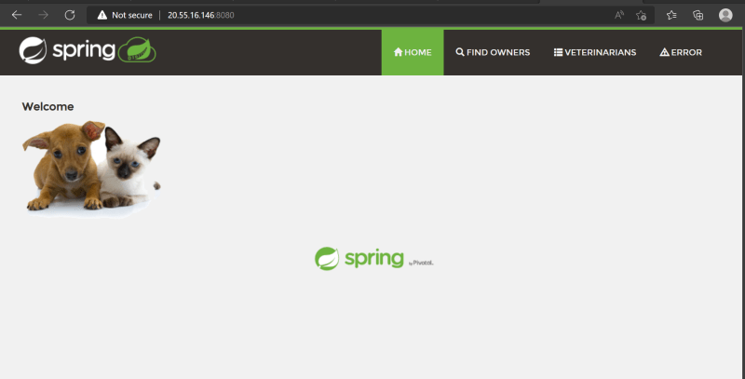

Creating a container image using Dockerfile – Approach 1
- https://docs.docker.com/engine/reference/builder/ for all the Dockerfile instructions
- For this activity lets stick closer to manual approach
  - Pick a base image => ubuntu:22.04
  - spring petclinic runs on port 8080
  - Steps to install are
bash
sudo apt update
sudo apt install openjdk-11-jdk -y
wget https://referenceapplicationskhaja.s3.us-west-2.amazonaws.com/spring-petclinic-2.4.2.jar
  - steps to start application => java -jar spring-petclinic-2.4.2.jar
- On a highlevel to choose a base image instruction is FROM
- To execute any commands to install/configure application the instruction is RUN
- To expose the port command is EXPOSE
- To start the application when container is created the instruction is CMD
- Lets try to write a Dockerfile
FROM ubuntu:22.04
RUN apt update
RUN apt install openjdk-11-jdk wget -y
RUN wget https://referenceapplicationskhaja.s3.us-west-2.amazonaws.com/spring-petclinic-2.4.2.jar
EXPOSE 8080
CMD ["java", "-jar", "/spring-petclinic-2.4.2.jar"]
- Now create a new folder and a file with Dockerfile as a name and cpy the above contents. Create the docker image
docker image build -t spc_one:1.0 .
docker image ls
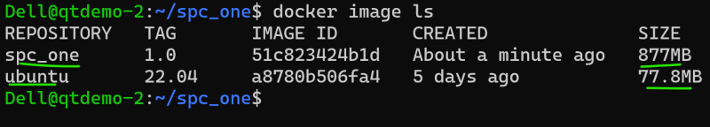
* Lets create a container in a detached mode with name processone
docker container run -d --name processone -p 8081:8080 spc_one:1.0
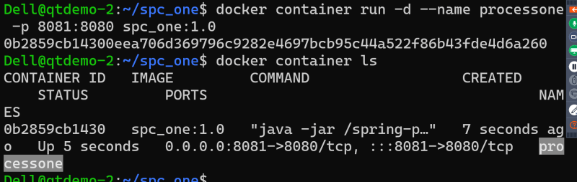
* Now access the application http://<vm-ip&gt;:8081
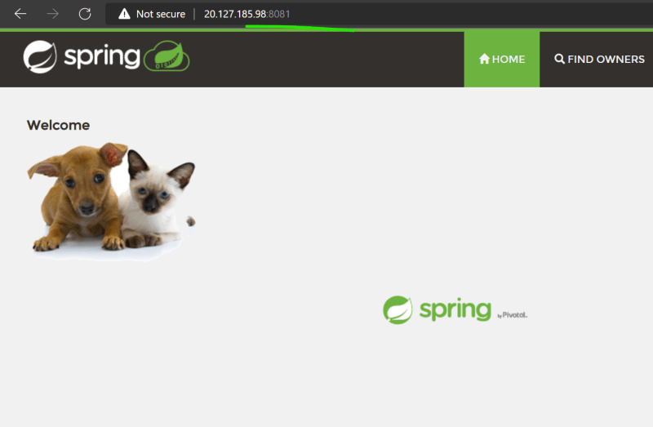

Approach 2:
- To run spring pet clinic i need java 11, but in the previous image i have started from ubuntu which is not necessary
- Lets use amazon correto https://hub.docker.com/_/amazoncorretto
- ADD instruction is used to copy the files into images
FROM amazoncorretto:11
ADD https://referenceapplicationskhaja.s3.us-west-2.amazonaws.com/spring-petclinic-2.4.2.jar /spring-petclinic-2.4.2.jar
EXPOSE 8080
CMD ["java", "-jar", "/spring-petclinic-2.4.2.jar"]
- Build the image docker image build -t spc_two:1.0 .
- list the images
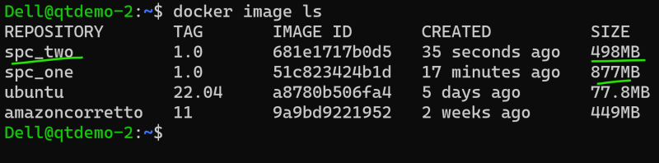
- Create the container docker container run --name processtwo -d -P spc_two:1.0
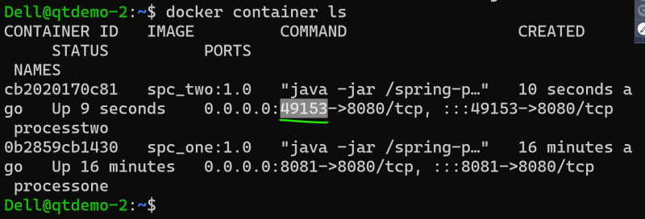
- Now access the application
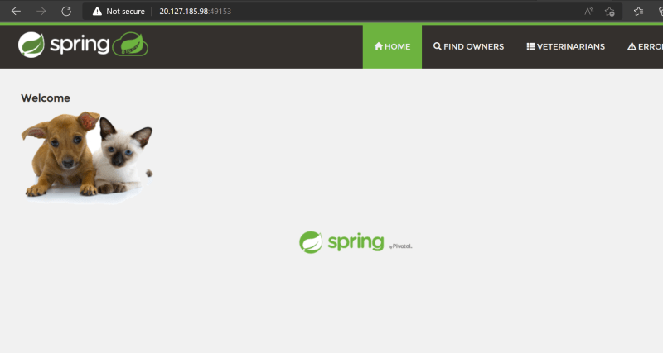
- Generally all the image publisher have slim options which further reduces the size of container on disk
- Exercise: Try using amazoncorreto:11-alpine-jdk as base image and build spc_three

